Cairo University  
Faculty of Computers and Information



**CS251**

**Software Engineering I**

2Yiin 2shya2ii

Software Design

Sherif Tarek, Aida Mohmoud, Dalia Ahmed

Month & Year

Contents

Instructions [To be removed] 3

Team 3

Document Purpose and Audience 3

System Models 3

I. Class diagrams 3

Important Algorithm 5

II. Sequence diagrams 5

Class - Sequence Usage Table 7

Ownership Report 8

Policy Regarding Plagiarism: 8

References 8

Authors 8

# Instructions [To be removed]

* **IMPORTANT. Rename this document to CS251-TAName-LeaderID-SDDocument.docx**

**(e.g. CS251-MohamedSamir-20040752-SDSDocument.docx)**

* **Remove the following notes and any red notes**
* **This document is the template document for your Software Design.**
* **For further guidelines and information, READ project details document (C251-SE2014-Project Description-v2.0).**

# Team

|  |  |  |  |
| --- | --- | --- | --- |
| **ID** | **Name** | **Email** | **Mobile** |
| 20160115 | Sherif Tarek Ragab | [Sherift1552@gmail.com](mailto:Sherift1552@gmail.com) | 01158789888 |
| 20160097 | Dalia Ahmed Abd El-Maged | [d.ahmed2112@gmail.com](mailto:d.ahmed2112@gmail.com) | 01099361085 |
| 20160125 | Aida Mahmoud Ewees | [anosh_a86@yahoo.com](mailto:anosh_a86@yahoo.com) | 01124351202 |

# Document Purpose and Audience

* **This document to set the functionality of the program and relations between them and how they interact to each other.**
* **Developers of this program should read this document to understand what to do in implementation phase and they may update it if needed.**
* **Project manager expect to read it to understand how the program will operate with the customer and try to inform CEO about them.**

# 

# System Models

## Class diagrams

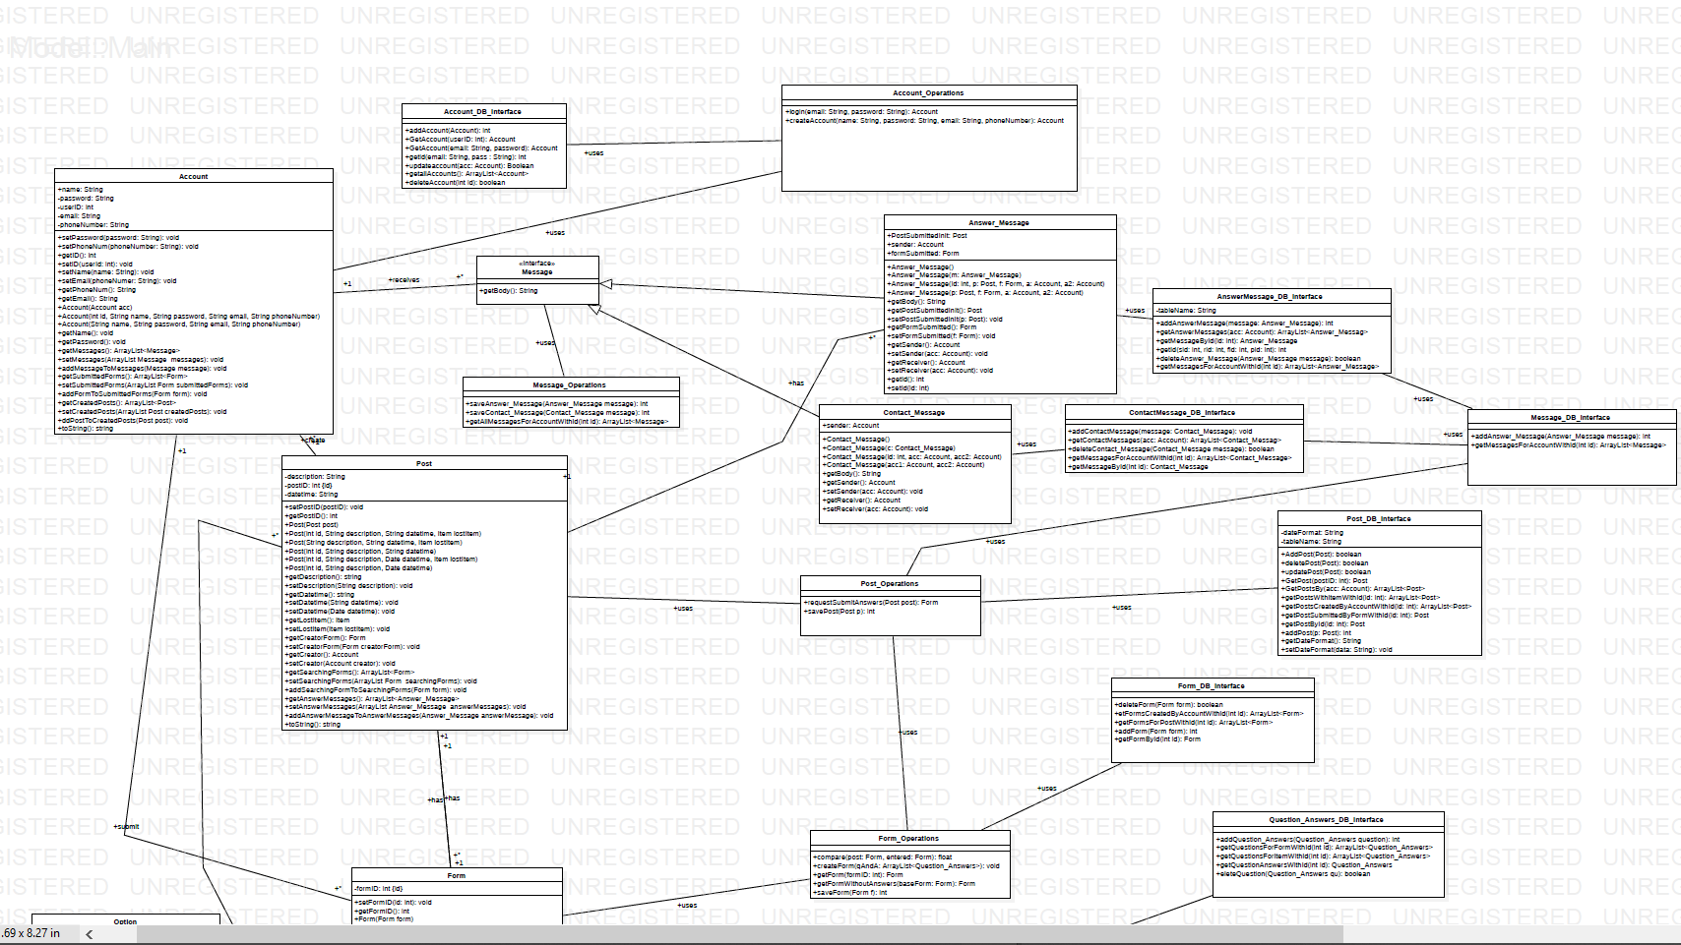

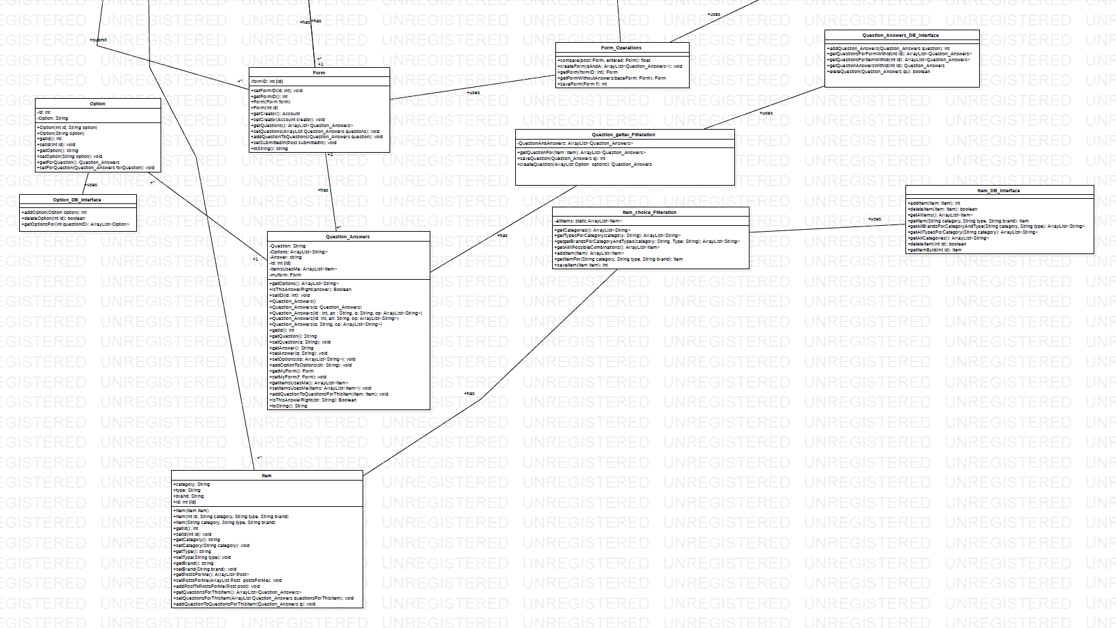

| **Class ID** | **Class Name** | **Description & Responsibility** |
| --- | --- | --- |
| 1 | Program_Interface | Has method that deals with user directly. |
| 2 | Account | Hold attributes of user accounts and methods to access them. |
| 3 | Account_info_Checker | Check about the validation of an account and edit the account information if needed. |
| 4 | Account_DB_interface | Deal with data of accounts in Database. |
| 5 | Form | Hold ID of form that created by user and method to compare the form of poster and the other forms which made by searchers. |
| 6 | Form_DB_interface | Hold database operations that will made on forms. |
| 7 | Questions_Answers | Has question and answers of form and methods to check if correct answers are more than 80% to decide whether to attach them with the post or delete them directly. |
| 8 | Question_getter_Filteration | Has methods to filter questions and options of that questions that will match specific item based on category, type and brand. |
| 9 | Message | Hold messages that user receives from system |
| 10 | Answer_message | Hold message contains |
| 11 | Contact_message | Hold messages that prepare contact information of searcher and send to the poster if the answers were right. |
| 12 | Post | Holds information about post and an object of form that created by poster and set of forms that created by searchers. |
| 13 | Post_Answers_attachment | Add right answer with a specific questions and submit it in the form. |
| 14 | Post_DB_interface | Holds operations that deals with database |
| 15 | Item | Attributes of item(category, type, brand). |
| 16 | Item_DB | Operations that deal with data base of class Item. |
| 17 | Item_choice_Filteration | Holds operations that filters posts that appears to searcher according to his choice. |

## 

## II. Sequence diagrams

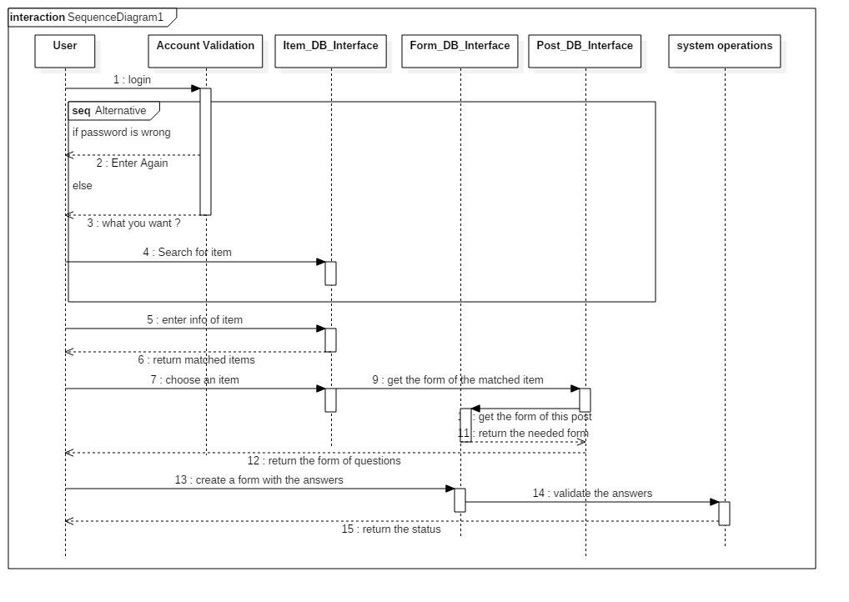

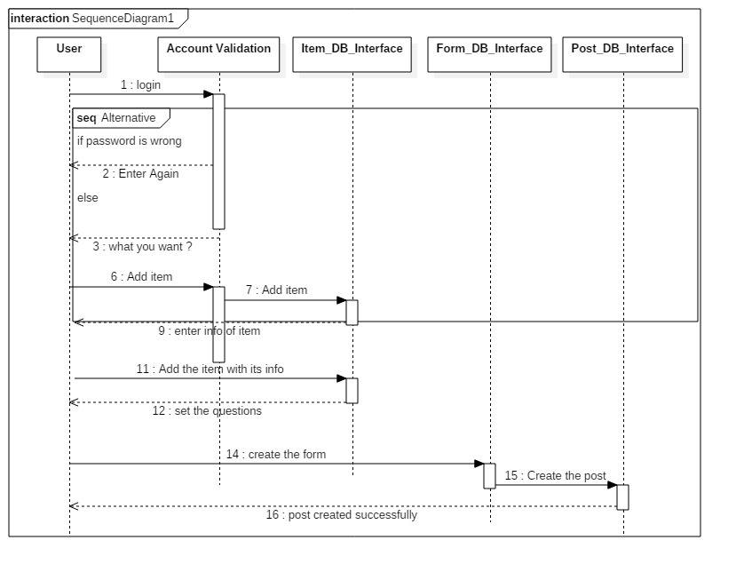

|  |  |
| --- | --- |
| **Item** | **Owners** |
| Sherif Tarek, Aida Mamoud | *Sequence Diagram* |
| Dalia Ahmed, Aida Mahmoud, Sherif Tarek | *Class Diagram* |

# References

* http://www.mhhe.com/engcs/compsci/pressman/graphics/Pressman5sepa/common/cs1/design.pdf

# Authors

* Mostafa Saad and Mohammad El-Ramly (Edited by Mohamed Samir)